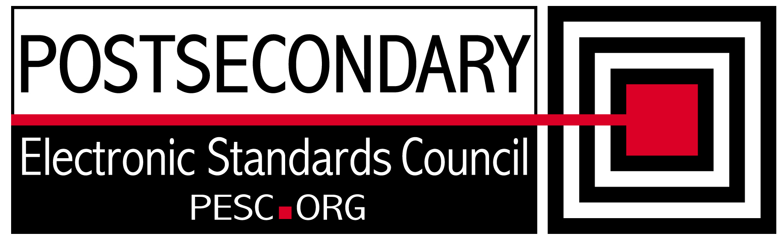

Standards Forum for Education
Status Update Form

Workgroup/Board/Group Name: | Technical Advisory Board
General Summary of Status: | Developed plan for single file schema and outline of how to use R&R
Status Flag (Red, Yellow, or Green): | Green
Report Date: | 10/8/2010
Projected Completion Date: | Standing Board
Item | Responsible Resource | Status
Planned Deliverables/Objectives:  - Component Architecture Approach  - Technical Approach to incorporation of CDS  - SIF Architectural Synchronization | Team  Team  Team | Tested new R&R. Created custom schema  On hold until CDS Implementation team mission is clearly defined  SIF architecture presented by Ron Kleinman of SIF
Accomplishments/Completions:
- Modified xslt that produces single file schemas so that only comments in the root schema are copied. Added version attribute
- Tested new R&R custom schema
Issues/Obstacles:
- Discuss with ED CTO responsibility to keep R&R up to date
Assistance Needed:
Chair(s)/Leader(s) Name(s): | Gideon Sanstra, Michael Morris
Meetings/Calls Since Last Update: | 4

Note: Chairs and/or leaders of workgroups, boards and committees under The Standards Forum for Education are required to provide updates during the Steering Committee’s monthly conference call meeting held the second Friday each month at 2:00pm EST. Call in information is: 866-352-3799 *7696363*. Forms must be completed and submitted prior to meeting time. Forms may also be posted on the PESC website as needed to provide the community at-large with a means to obtain updates for ongoing, but yet to-be-completed development efforts.

